View Controllers:

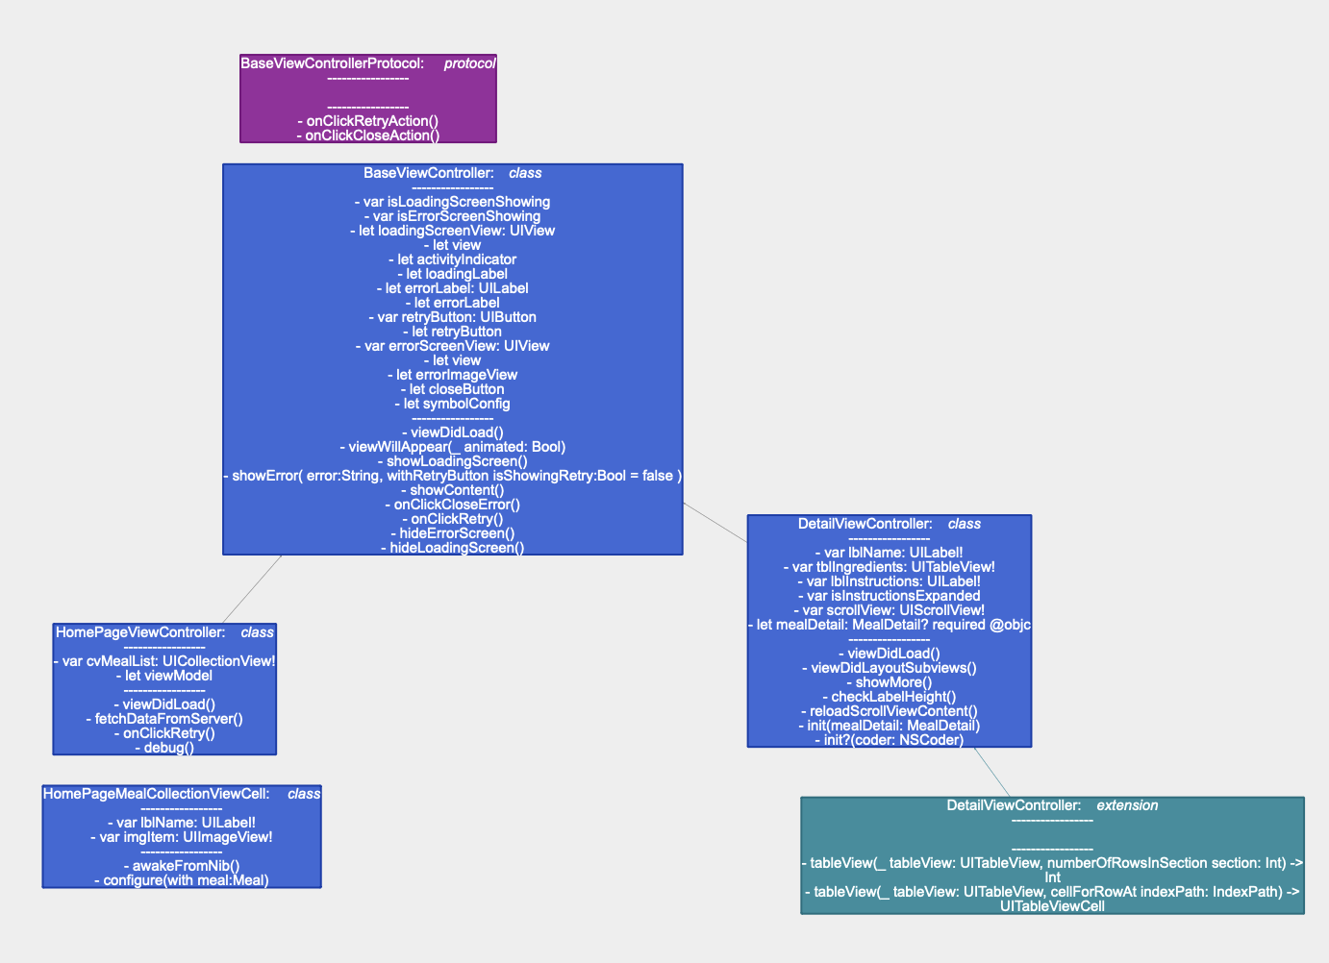

**Modal Classes**

Interface Object server response

Network:

**XCTestCase**

